Student ID: 10134030

November 30, 2018

Data Analytics - Final Project

Professor David Skillicorn

**Introduction – Strategy:**

A six-step approach will be implemented to analyse the data which is illustrated in Figure One. First, a business understanding is established to justify the analysis of the dataset. Second, data understanding entails probing the dataset to uncover any obvious patterns and to visualise the data’s structure. Third, data preparation involves reorganising the dataset as a precursor to modelling. Fourth, the models are created to satisfy the business need identified in step one. Fifth, the model’s performance will be evaluated to ensure the model accurately depicts the behaviours present within the dataset. Finally, the model is deployed to the market place. The order in which the project steps occur are not perfectly sequential; therefore, there may be multiple iterations between steps before creating the best model. Any setbacks experienced during the model creation process will be identified in the analysis below.

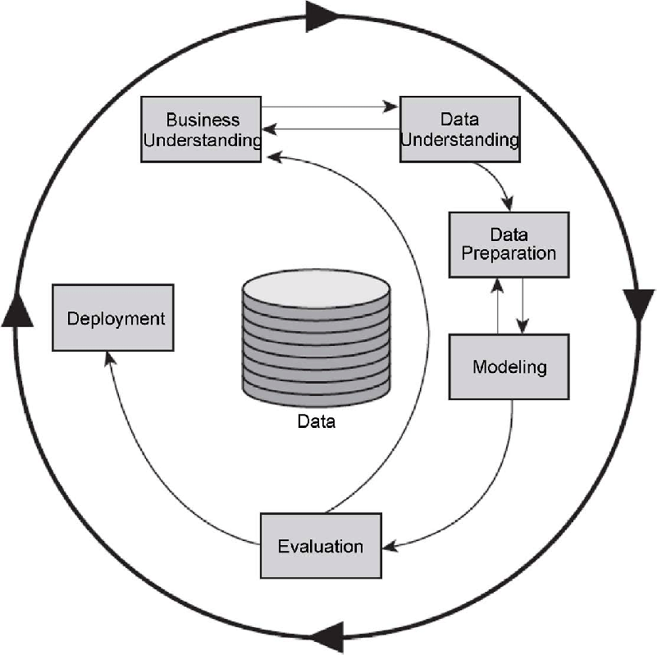

Figure 1 – Project Design

**Business Understanding:**

The project’s purpose is to identify the causes of churn among the ISP’s customers. There are multiple benefits to knowing when and why a customer wishes to leave. With this predictive knowledge, the business can prevent departures through multiple marketing tactics. First, the business can offer promotional packages to customers who possess a higher likelihood of departure. Second, the ISP can create new effective product lines that alleviate customer’s grievances. Finally, the business can focus internally on enhancing business operations to supply a more pleasurable experience. Overall, the project aims to empower the business to make evidence-based decisions rather than solely relying on incomplete intuitions.

**Data Understanding:**

Prior to extracting insights from the data, the data’s integrity was tested to determine the number of missing values. There were eleven missing data points in total, each from the same column but within different records. These records were removed because there was enough data to nullify the effect of deleting the incomplete records. After reaffirming the data’s integrity, the first step was to investigate the dataset through descriptive statistics, which is displayed in Figure Two.

Figure 2 - Descriptive Statistics Excluding Categorical Variables

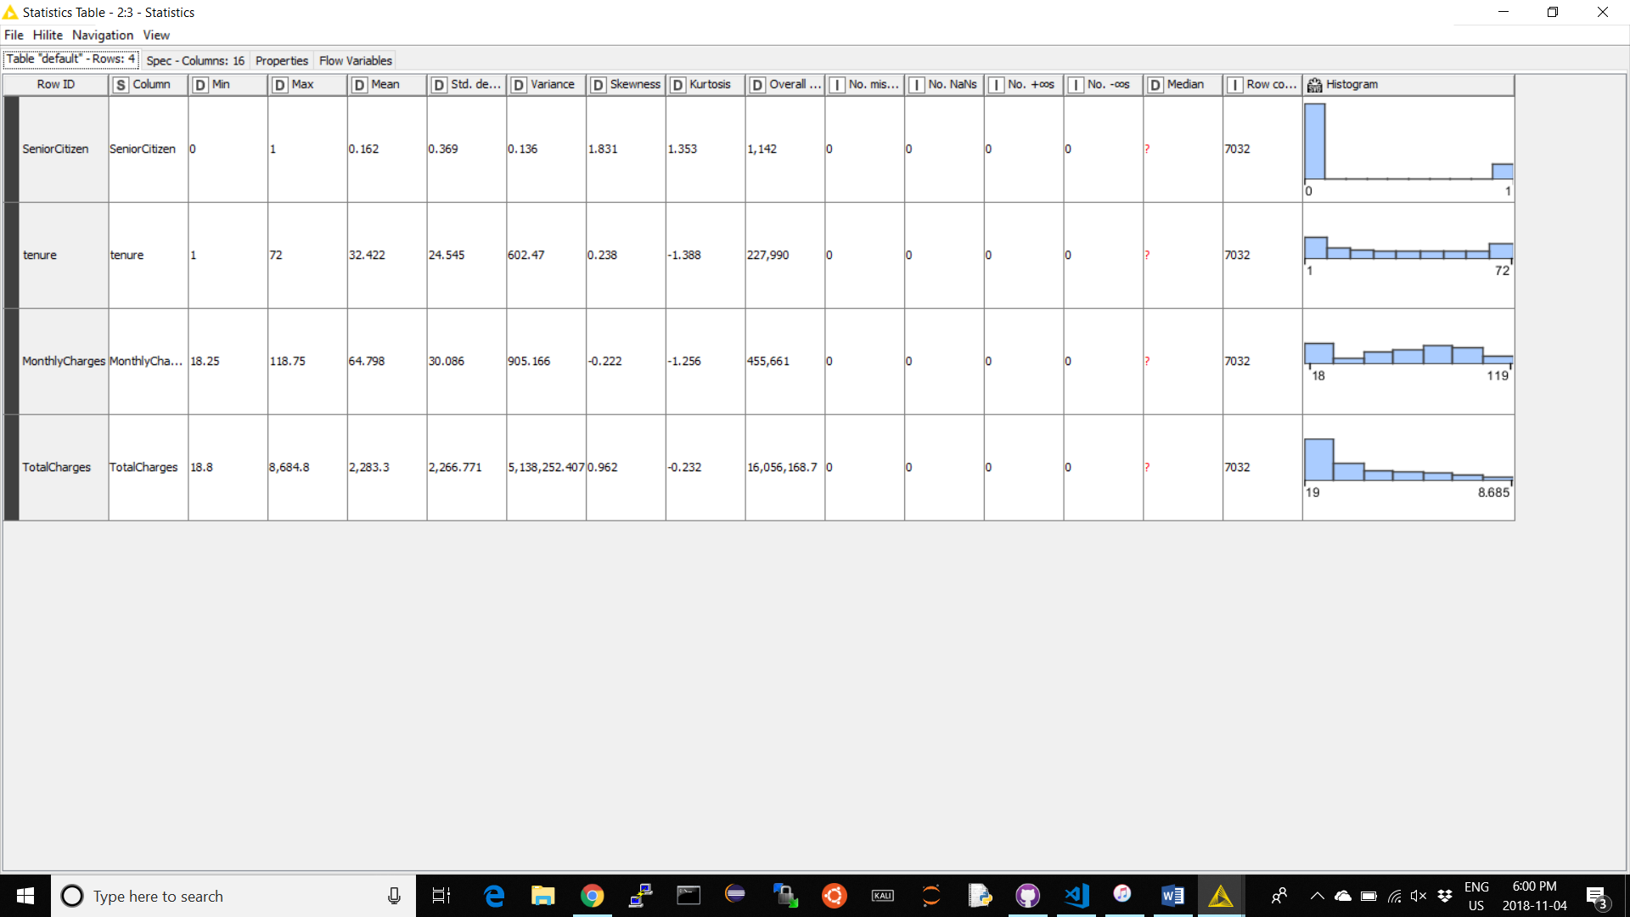

The image does not provide much insight about the causes for churn; nonetheless, the descriptive statistics illustrate the data’s distribution. ‘Tenure’ and ‘Monthly Charges’ both contain similar skewness and kurtosis values; therefore, their data distribution form a platykurtic curve. Furthermore, ‘Total Charges’ is characterised by a mesokurtic curve with more data skewed left of the mean.

Furthermore, histograms were produced to understand the distribution of the categorical variables. The created histograms contained data that was relatively uniformly distributed with some exceptions shown in Figure Three. The non-seniors greatly outnumber the seniors, customers without dependents slightly outnumbers customers with dependents, and customers with phone service heavily outnumbers customers without phone service.

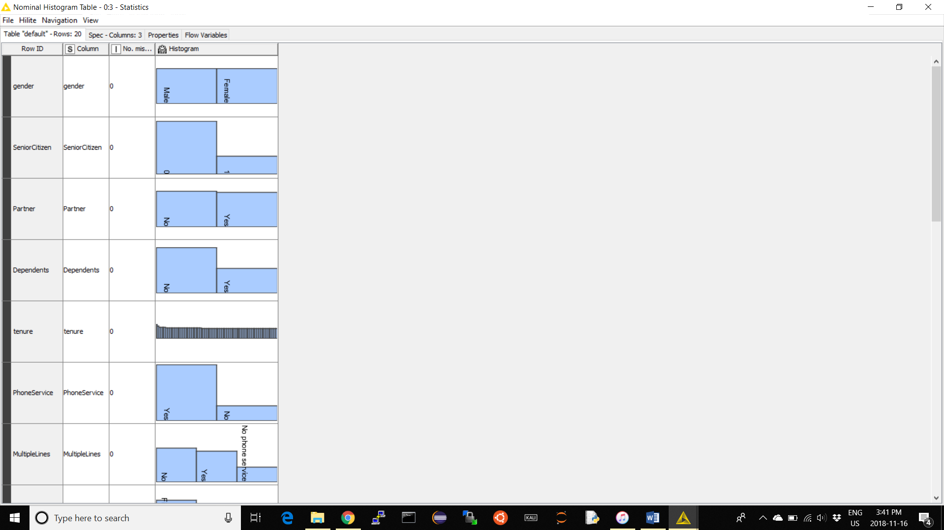

Figure 3 – Distribution of Categorical Variables

Finally, the correlation between the features was extracted to garner additional insights. There are two intriguing discoveries the correlation map displays in Figure Four. The dark blue areas indicate positive coefficient values while red indicates negative coefficient values. The centre of the map contains a large blue square with the following features: ‘InternetService’, ‘OnlineSecurity’, ‘OnlineBackup’, ‘DeviceProtection’, ‘TechSupport’, ‘StreamingTV’, and ‘StreamingMovies’. Since these features are highly correlated with one another, it indicates that consumers who possesses ‘InternetService’ are likely to purchase the other indicated features resulting in higher monthly charges. Furthermore, higher total charges correlate positively to higher monthly chargers, the existence of a partner, the presence of dependents and a longer tenure.

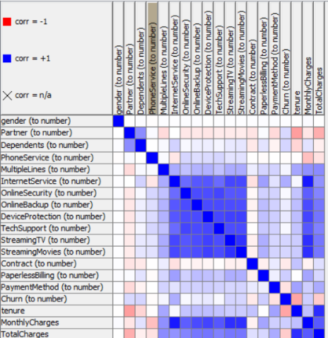

Figure 4 – Correlation Map

The data’s description is also important to understanding; however, since the feature titles are self-explanatory, there will not be an explicit attribute descriptions.

**Data Preparation:**

Data preparation involves modifying the data for modelling purposes. Although the figures above were created within Knime, the remainder of the project will be completed using Jupyter. Knime screenshots and the Jupyter code will be included at the end report.

First, the data was read into a ‘pandas’ data frame. The data was partitioned into a feature set and an outcome set. The feature set included every attribute except ‘customerID’ and ‘churn’. The churn was excluded because it is the target variable. The ‘customerID’ attribute was dropped since it yields no predictive value.

Second, each categorial feature was tested to find the number of ways it could be classified. Since each feature contained less than five categories, the classifications were not aggregated using PCA. Furthermore, each categorical variable was converted into dummy variables. For example, the feature ‘InternetService’ contains three possible outcomes: DSL, Fiber Optic, and No Internet Service. Rather than assigning a number to each classification, the feature itself was converted into dummy variables. Therefore, if the user possessed DSL, the ‘InternetService_DSL’ feature was assigned a 1 while ‘InternetService_Fiber Optic’ and ‘InternetService_No’ features were assigned 0s. Dummy variables were used to prevent misconceptions regarding attribute importance when modelling. For example, encoding Internet service type within one attribute will require three numbers for each classification. Assigning the ‘InternetService_No’ class the value 3 and ‘InternetService_DSL’ class the value 1 will mislead some models to believe that ‘InternetService_No’ is three times the importance of ‘InternetService_DSL’.

Next, the data was randomly split into two sets: the test data received 20% of records while the training date received the other 80%. The best features were then identified utilising the ‘selectKBest’ algorithm from sklearn. This function chooses the k-best features from a set by scoring them based on their ANOVA f-value thus indicating attributes that cluster customers together. The first ten attributes with the highest k values were selected to potentially model the data. In addition, a ‘Random Forrest Classifier’ was utilised to verify the ‘selectKBest’ attribute selection process. The classifier was created using 100 trees which is approximately the amount of records squared. From the generated model, the 10 most important features were identified. Figure Six illustrates a comparison between both attribute selection algorithms.



Figure 6 – Attribute Selection

The attribute sets selected by each algorithm contained similarities and differences. The tenure feature was identified to be important in both selection algorithms. Nonetheless, the Random Forest placed more importance on total charges and monthly charges while ‘selectKBest’ favoured Fiber Optic and No Online Security. The features picked by ‘selectKBest’ relates to results found within the correlation matrix because customers without online services seem to share similar customer profiles. Furthermore, only ten attributes were selected using each selection algorithm because additional attributes failed to enhance model performance and sometimes resulted in performance drops. In addition, subsets from the selected attributes above were tested to see whether different attributes affected model performance; however, this process will be explained next section since there exists a feedback loop between Data Preparation and Data Modelling.

**Data Modelling:**

To begin, five models were created from the attribute set above including K-Nearest Neighbours, Decision Tree Classifier, Logistic Regression, Random Forest Predictor, and an Ensemble Learner. First, K-Nearest Neighbours was chosen to identify possible clusters within the data. Based on the observations from the correlation matrix and ‘selectKBest’, there is a possibility that there are a group of customers that share similar behaviours. Second, the Decision Tree was created to understand the behaviour of other models. Decision Tress produce an intuitive picture that can reveal the reason for customers churn. Third, a Logistic Regression was created because it is designed for classification problems and can explain causality unlike other Blackbox models; furthermore, a strong Logistic Model can be created with the amount of given records compared to a Neural Net which requires much more data. Fourth, a Random Forest Classifier was created because of its strength as a classifier and of its ability to avoid overfitting. Finally, the ensemble learner, Vote Classifier, was created to have every model vote on a single record to predict the customer’s outcome; therefore, the ensemble learner could produce an improved model by using the intuition behind the ‘wisdom of the crowds’.

To ensure the essential attributes were plucked from the original attribute set, the union between the selectKBest attribute set and the RandomForest attribute set were used to model the data. Figure Seven below shows three types of attributes: green attributes were selected by both algorithms; blue attributes were uniquely selected by selectKBest and red attributes were uniquely selected by the Random Forest predictor.

Figure 8 – Model Results using attributes in Figure 7.

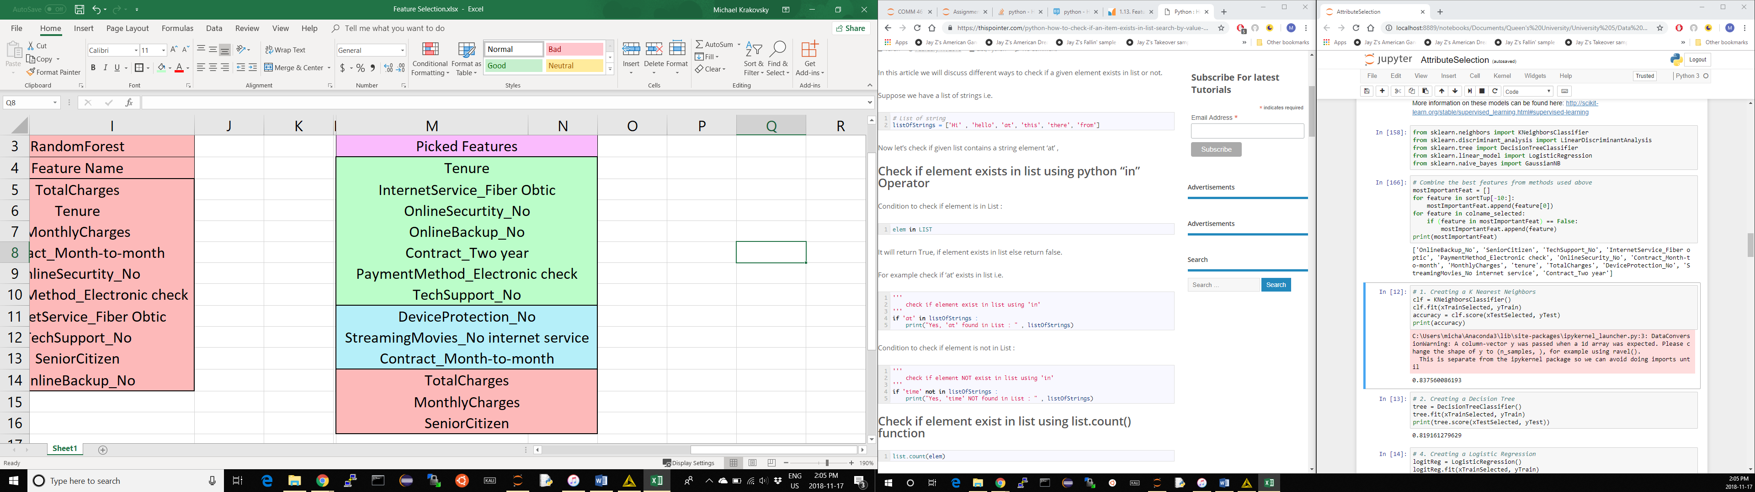

Figure 7 – The Attribute Set resulting in the best intial model performance.

The model results when using the attributes from Figure Seven are shown in Figure Eight. The table is ordered by increasing model performance. As noted in the previous section, different attribute sets were used in attempt to create better models. Three series of models were created using three different feature sets: the attributes uniquely selected by selectKbest, the attributes uniquely selected by the Random Forrest Selector, and the attributes intersecting both selection algorithms. The union of attributes from both selection algorithms consistently yielded the best results; however, model performance was enhanced by changing the model’s default parameters.

**K-Nearest Neighbours:** First, the number of neighbours was increased from 5 neighbors to 9. The number of neighbours was an odd number to avoid ties in voting; furthermore, increasing the neighbours from 9 hindered performance.

**Decision Tree**: First, the min_samples_split and min_samples_leaf parameters were changed from their default values of one but caused no change. Nonetheless, when the max_depth of the tree was limited to 5, the accuracy of the tree increased by 2.49%.

**Logistic Regression:** First, the l2 the penalty function produced a better model then using the l1 penalty function. In addition, the solver function was set to ‘liblinear’.

**Random Forest**: First, the n_estimators was maintained at 100 trees resulting in the best model accuracy. Second, the entropy criterion was used, which is a function that measures the quality of a split, but there was no change in model performance. Finally, the max_depth was altered; however, the model produced better results without a maximum depth.

**Voting Classifier:** First, the vote parameter was set to soft, which predicts the class label based on the argmax of the sums of the predicted probabilities; however, hard voting produced better results.

The tweaked models are shown in Figure Nine.

Figure 9 – New Model Results



**Evaluation:**

The best performing models were the Random Forest and Logistic Regression. To further inspect model performance, the AUC chart, gain charts, and lift curves were graphed. The gains chart shows the cumulative records captured by the model throughout the entire data set. Figure Ten displays the Logistic Regression’s performance while Figure Eleven illustrates the Random Forrest Classifier’s performance.

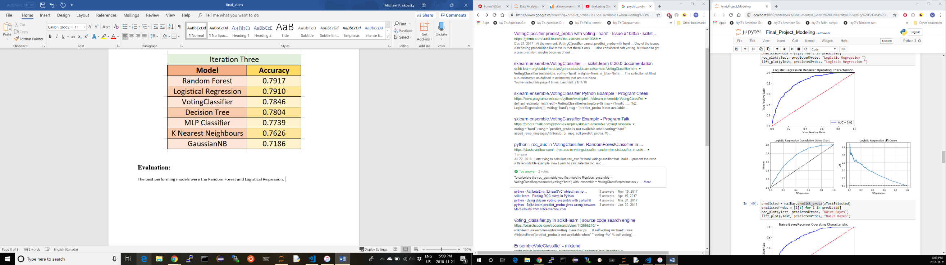

Figure 10 – Logistic Model Performance

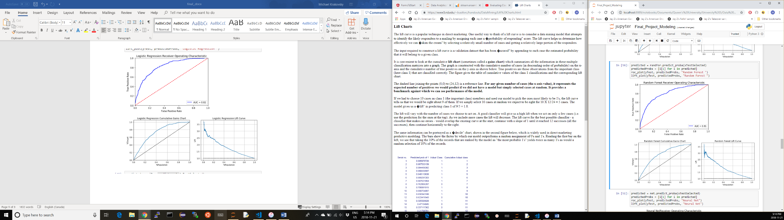

Figure 11 – Random Forrest Performance

The Random Forrest Classifier and Logistic Regression share similar performance measurements. The Random Forrest Classifier obtained a better accuracy than the Logistic Regression by seven basis points; however, the Logistic Regression possess a greater AUC than the Random Forrest Predictor by one percent. In addition, the Logistic Regression’s recall and precision was recorded at 79%. The recall and precision are important measurements because they indicate whether the model contained an excessive number of false positives or false negatives. The model did not favour choosing one classification over the other since these scores are consistent with the model’s accuracy. There was an attempt to enhance the Logistic Regression through gradient boosting and bagging; however, the new model generated unfavourable results. Although the Random Forrest’s and Logistic Regression are equivalent in performance, the Logistic Regression is the preferred model. The Logistic Regression matches the Random Forrest in performance; however, it requires two fewer minutes of computational time.

**Customers with Tenure Greater Than One Year:**

The modelling process will be repeated for clients with a tenure greater than one year to observe possible differences. The Data Understanding and Data Preparation steps will be skipped since they are identical to the initial process. The process begins to change when the attributes are selected. Figure Twelve illustrates the union of sets between the ‘selectKBest’ and ‘Random Tree Classifier’ feature selection algorithms once the data was partitioned.



Figure 12 – Attributes: Tenure >12



Figure 13 – Models: Tenure >12

Despite removing customers with tenure of a year or less, the attributes are quite similar except for the replacement of two attributes. Figure Thirteen above reflects the created models with the optimal parameters. The models created in the second analysis are alike to the new models since there was little change in the attributes; however, the vote parameter within Voting Classifier was changed from hard to soft. There was an increase in performance which was caused by partitioning the dataset based on tenure since new consumers behave differently from those who have been with the company for more than a year. The Logistic Regression outperformed all other models during the second iteration including an increased recall and precision score of 81%. The improved Logistic Regression model is shown in Figure Fourteen.

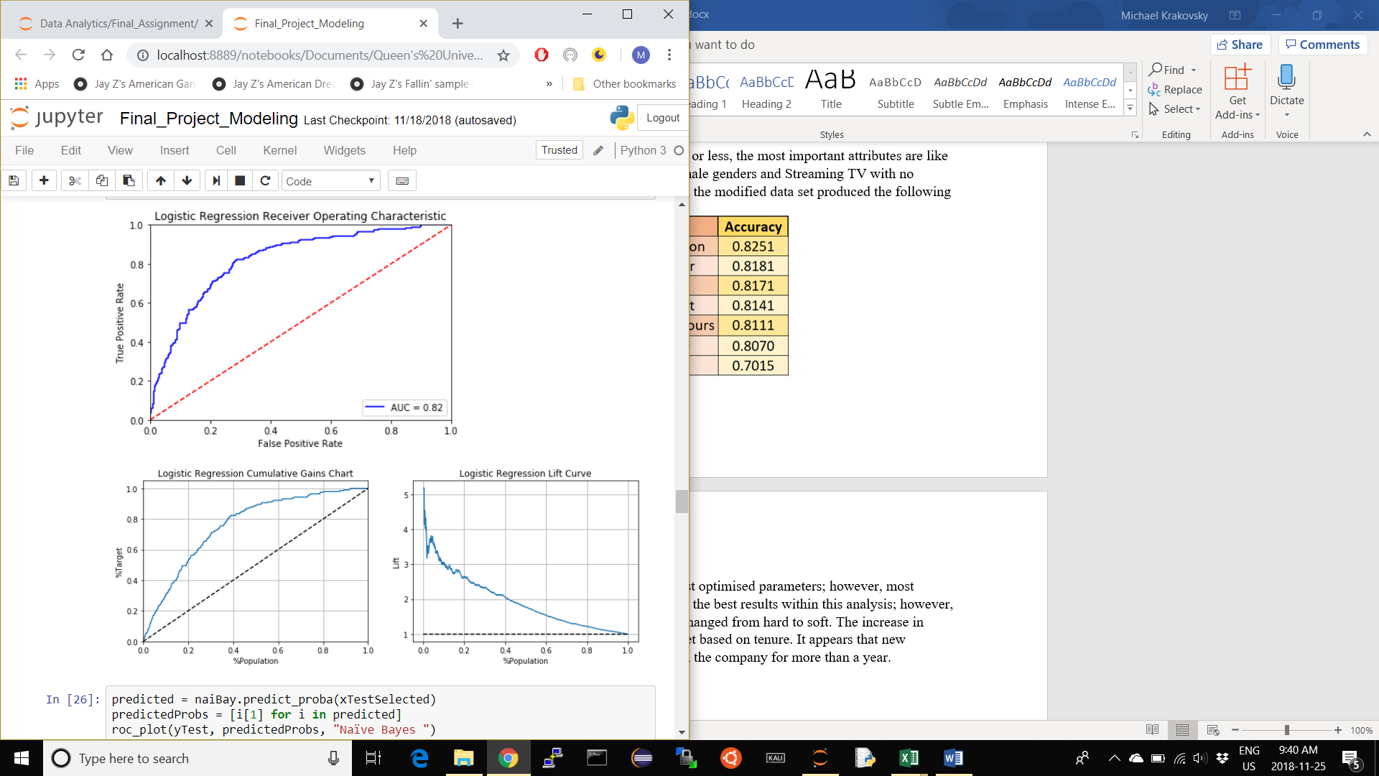

Figure 14 – Logsitic Regression Performance

**Recommendations & Deployment:**

The Logistic Regression odds ratios derived from the previous section indicates casual factors for churning. In Figure Fifteen, features with odds ratios greater than one indicate an increase in probability to churn. For example, while keeping all other variables constant, customers who possess fiber optic are 125% more likely to churn than consumers without fiber optic. This may indicate to the business that the quality of their fiber optic service is poor or expensive; nonetheless, the business may want to investigate their fiber optic package. Next, customers are more likely to churn when they have a month-to-month contract compared to a two-year contract while each additional month you stay with the ISP will lower you chances of churn by 7.17%. Since consumers who were with the ISP for less than a year are likely to possess month-to-month contracts, these consumers churn quickly. Finally, customers who pay with an electronic check are more likely to leave; therefore, the payment method may create dissatisfaction among the ISP’s customer base or the competition may provide more innovative payment methods.

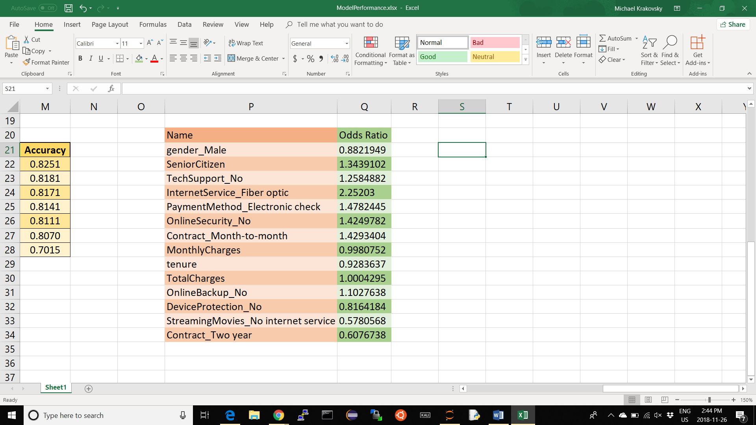

Figure 15 – Logistic Regression Odds Ratio

The final recommendation is a two-pronged approach that requires the customer to initially commit to the ISP and then maintains their commitment through a strategic marketing campaign. The first approach addresses the issue of customers churning when they have been with the company for less than a year. The business should enforce two-year contract signings to all new customers to prevent early churn. Within this two-year time span, the business can collect more relevant data for additional modelling such as consumer disposable income, customer satisfaction scores, and consumer price sensitivity. Second, once the customer remains with the company, the business can successfully predict churn with 82.51% accuracy using the model above. If the model identifies a customer more likely to leave, the business can remedy the customer’s contempt therefore creating a tailored service designed to prevent unnecessary churn.

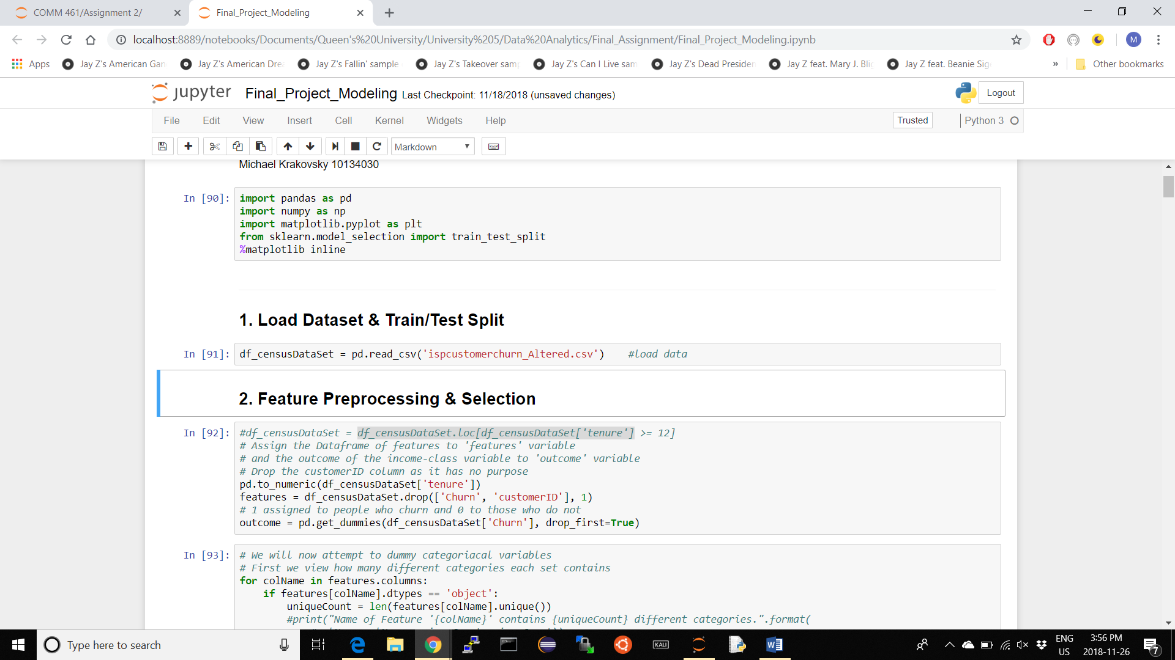**Code and Knime Screenshots:**

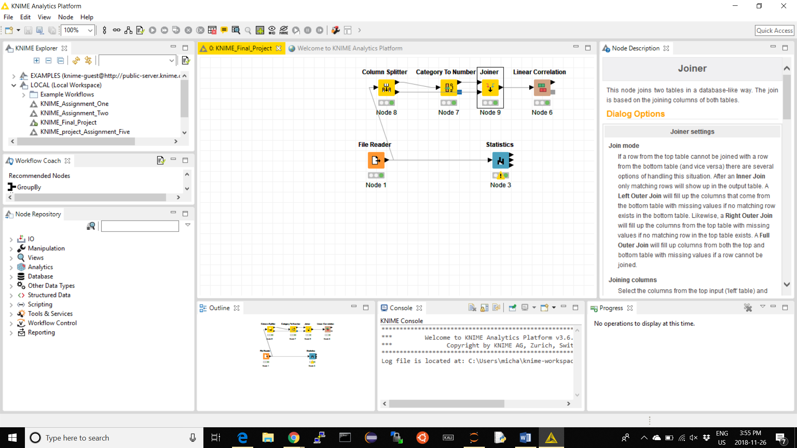

**1**

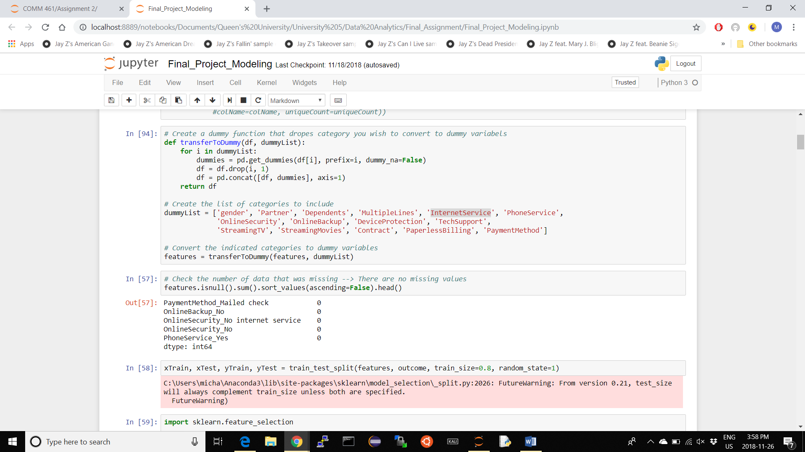

**2**

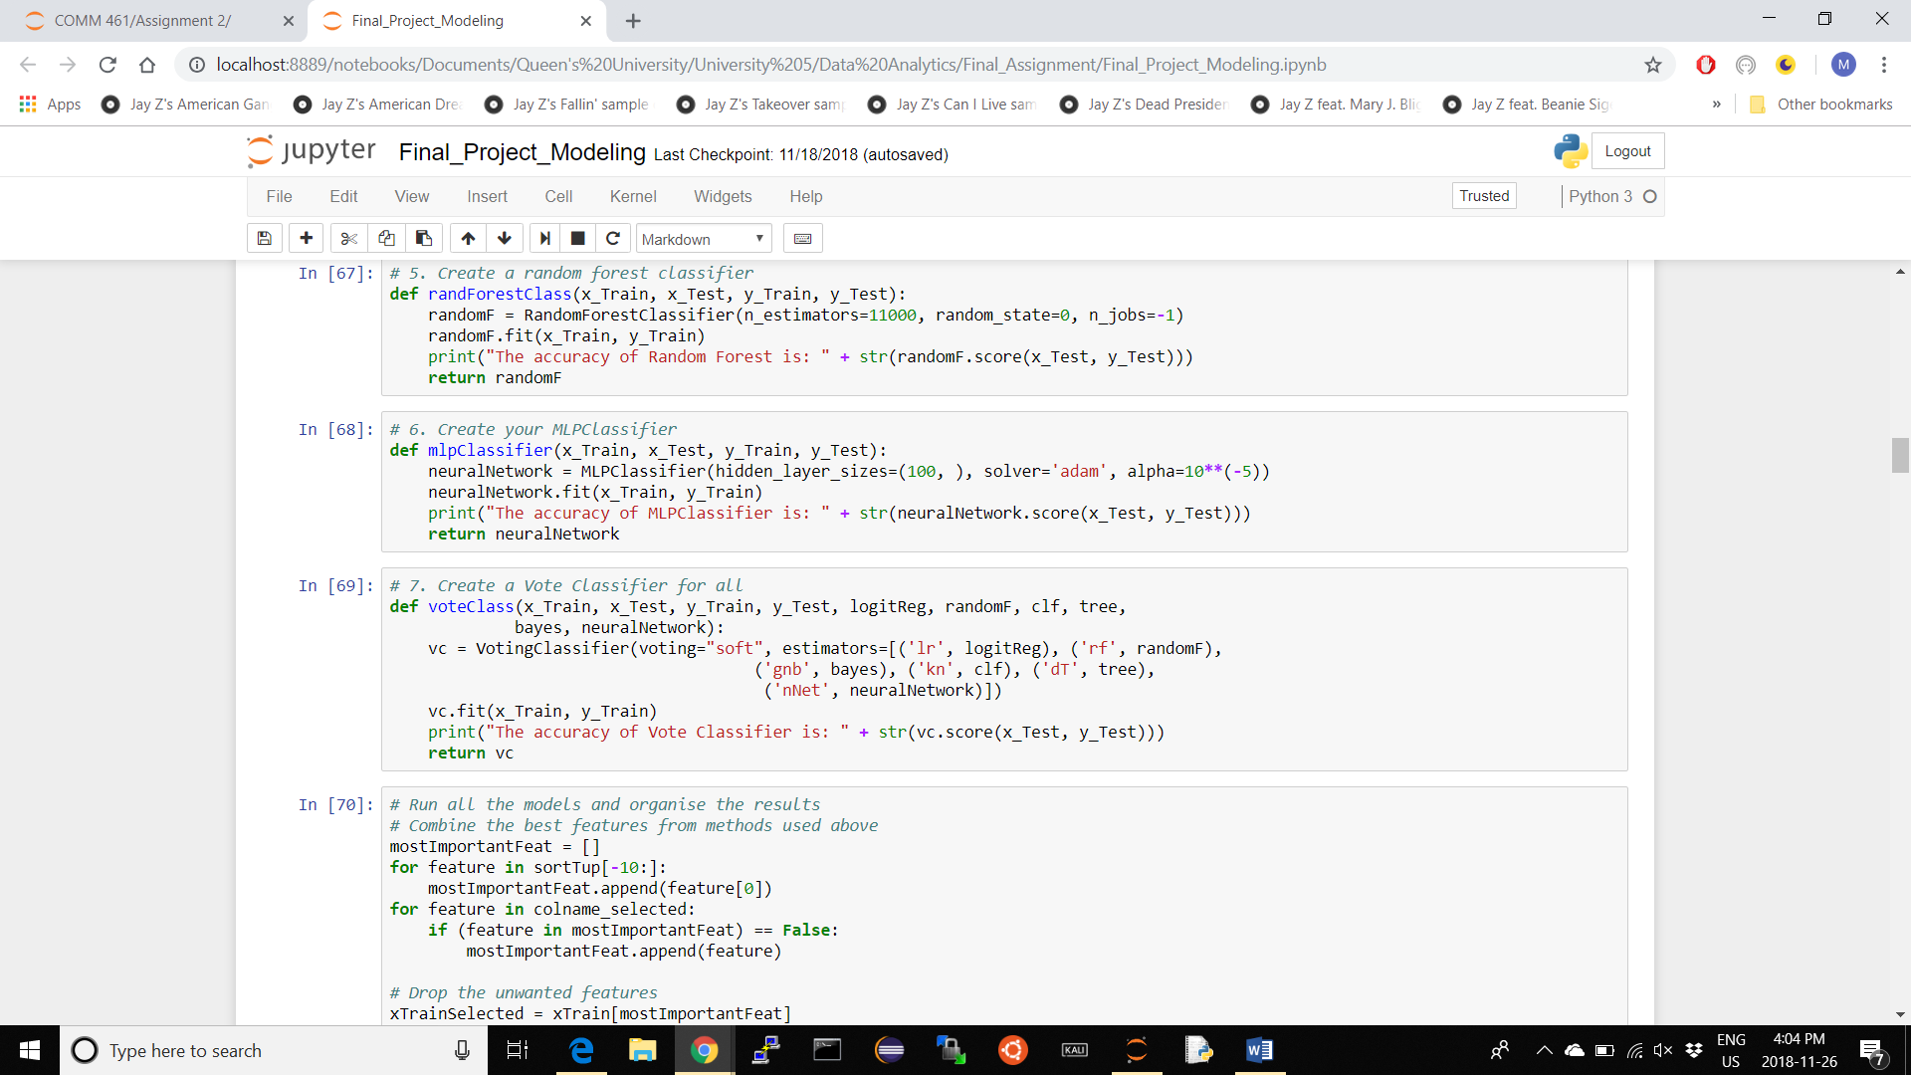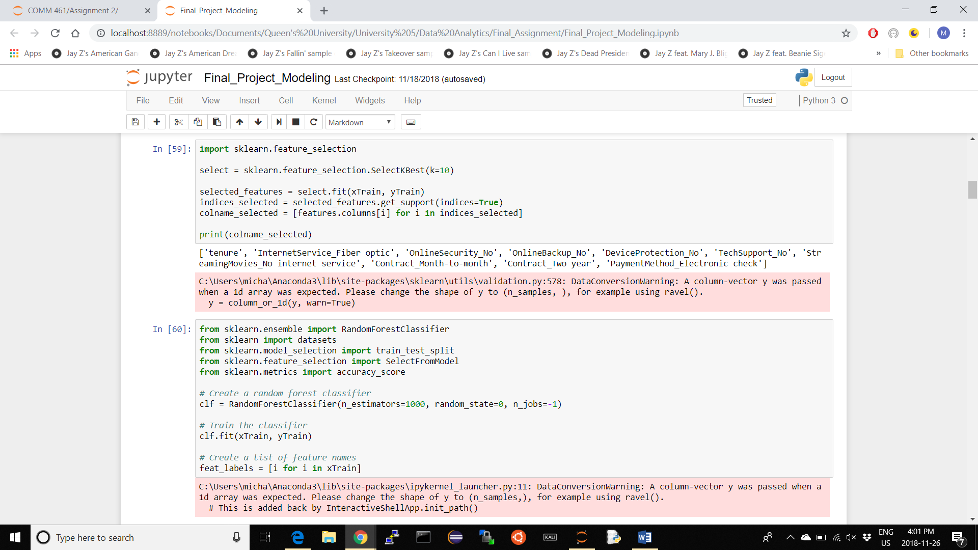

**3**

**6**

**7**

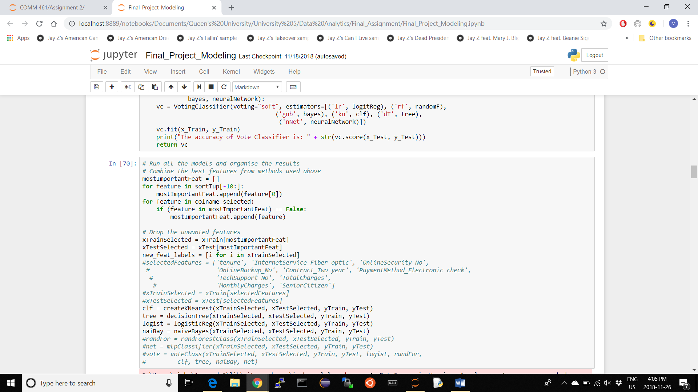

**4**

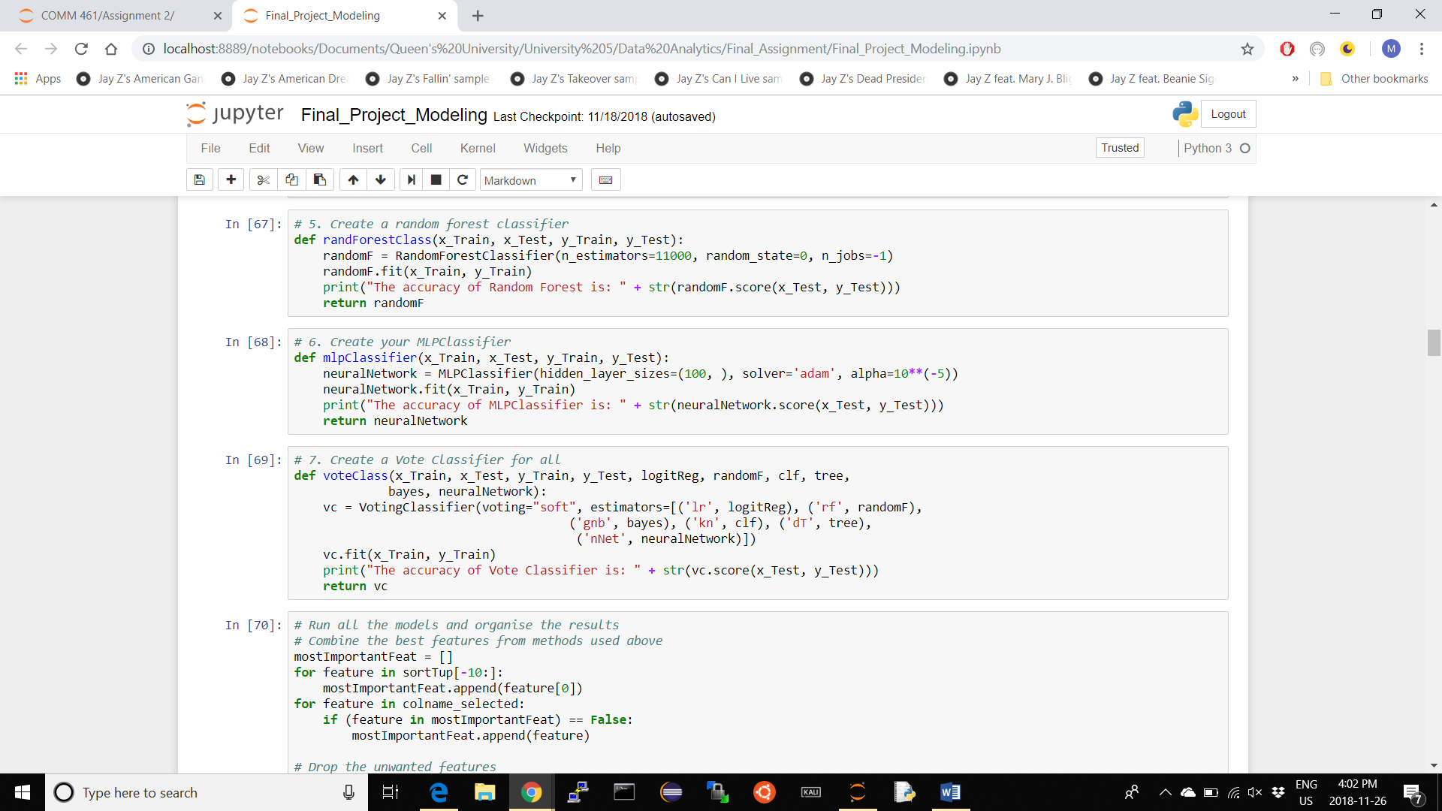

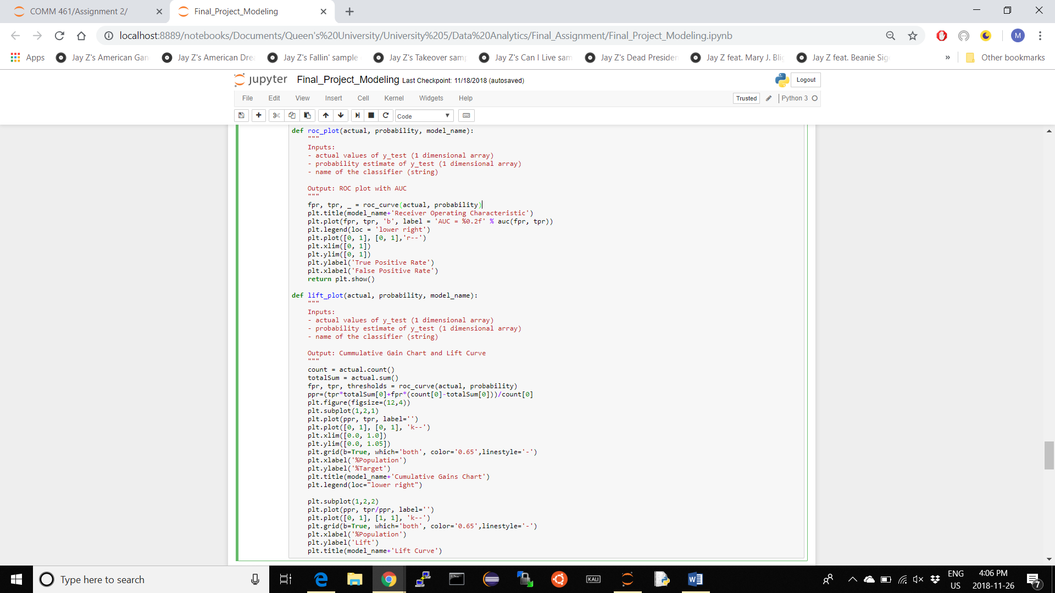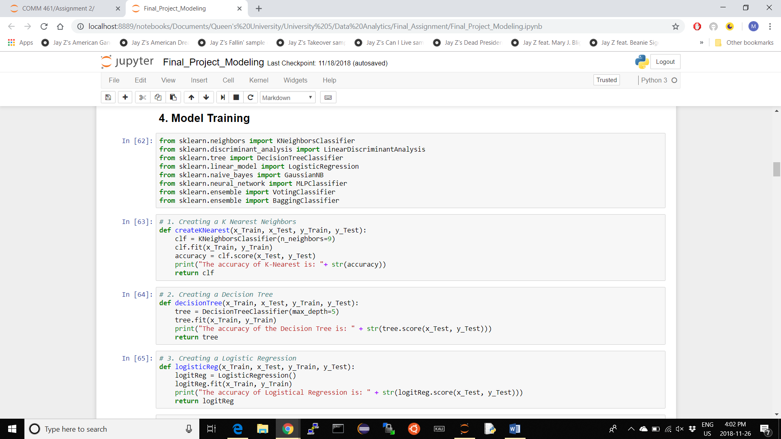

**8**

**5**